CAPABILITIES DOCUMENT

Project: ECSE 211 Search & Retrieval Robot
Task: Overall design

Document Version Number: 1.1
Date: February 18, 2020
Author: Yanis Jallouli
Edit History:
Date | Version | Author(s) | Changes
Feb 18 | 1.0 | Yanis Jallouli | Initial Draft
Feb 18 | 1.1 | William Bouchard | Formatting of the document  Updated Section 3.0 for everyone

1.0 TABLE OF CONTENTS
2.0 – TEAM MEMBERS 3
3.0 – CAPABILITIES 4
4.0 – POSSIBLE APPLICATION AREAS 5
5.0 – AVAILABILITY 6
6.0 – GLOSSARY OF TERMS 7

2.0 – TEAM MEMBERS
NAME EMAIL PHONE
William Bouchard - william.bouchard3@mail.mcgill.ca 418-573-0193
Yanis Jallouli - yanis.jallouli@mail.mcgill.ca 727-542-0435
Andy Li - andy.s.li@mail.mcgill.ca 438-938-8088
Trevor Tabah - trevor.tabah@mail.mcgill.ca 514-887-4081
Benjamin Weiss - benjamin.weiss3@mail.mcgill.ca 647-876-6100
Seyed Yazdan Zinati - seyed.zinati@mail.mcgill.ca 438-600-1913

3.0 – CAPABILITIES
Name | Software  Experience | Hardware  Experience | Testing  Experience | Organization | Leadership
William Bouchard | Proficient in Java, C, Python, Dart  Experience with Git and Github  Experience with Object Oriented Programming | Very basic circuit analysis (ECSE 200)  Experience with Lego | JUnit tests  Frontend tests (Vue) | Created a soccer team from scratch and organized it for 2 years | Leadership role in sports team.
Yanis Jallouli | Proficient in Java and C++ development.  Minor experience with Git and GitHub | Basic circuit analysis (ECSE 210) | Designed Unit and integration tests  (ECSE 321) | No experience | Leadership role in sports team.  No formal team management experience
Andy Li | Some experience in Java and C++ | Experience with Lego Mindstorms  Circuit and signal analysis (ECSE 200, 206, 210, 222) | No formal testing experience | Executive organizational role in major club (2 years)
Trevor Tabah | Proficient in Java and Python Development | No experience | JUnit tests (ECSE321) | No experience | Leadership roles in numerous sports teams
Ben Weiss | Proficient in Java building, developing & debugging.  Experience with Agile Development (ECSE 321) | No experience | Created JUnit tests  (ECSE 321) | No experience | Managed groups of 5-6 in business case competitions
Seyed Yazdan Zinati | Proficient in Java and concept of OOP  Experienced in Python, C and C++ | Circuit analysis  Signals and systems  Controls | No formal testing experience | Managed a small team in a programming competition for 2018 RoboCup | Leadership roles in group projects and sports

4.0 – POSSIBLE APPLICATION AREAS
NAME | Software | Hardware | Testing | Organization | Leadership
William Bouchard | X | O | O | O
Yanis  Jallouli | O |  | X |  | O
Andy  Li | O | O |  | X
Trevor  Tabah | O |  | O |  | O
Ben  Weiss | O |  | O |  | X
Yazdan  Zinati |  | X |  | O

O = Capability (self-assessed)
X = Assigned to (and capable of)

5.0 – AVAILABILITY
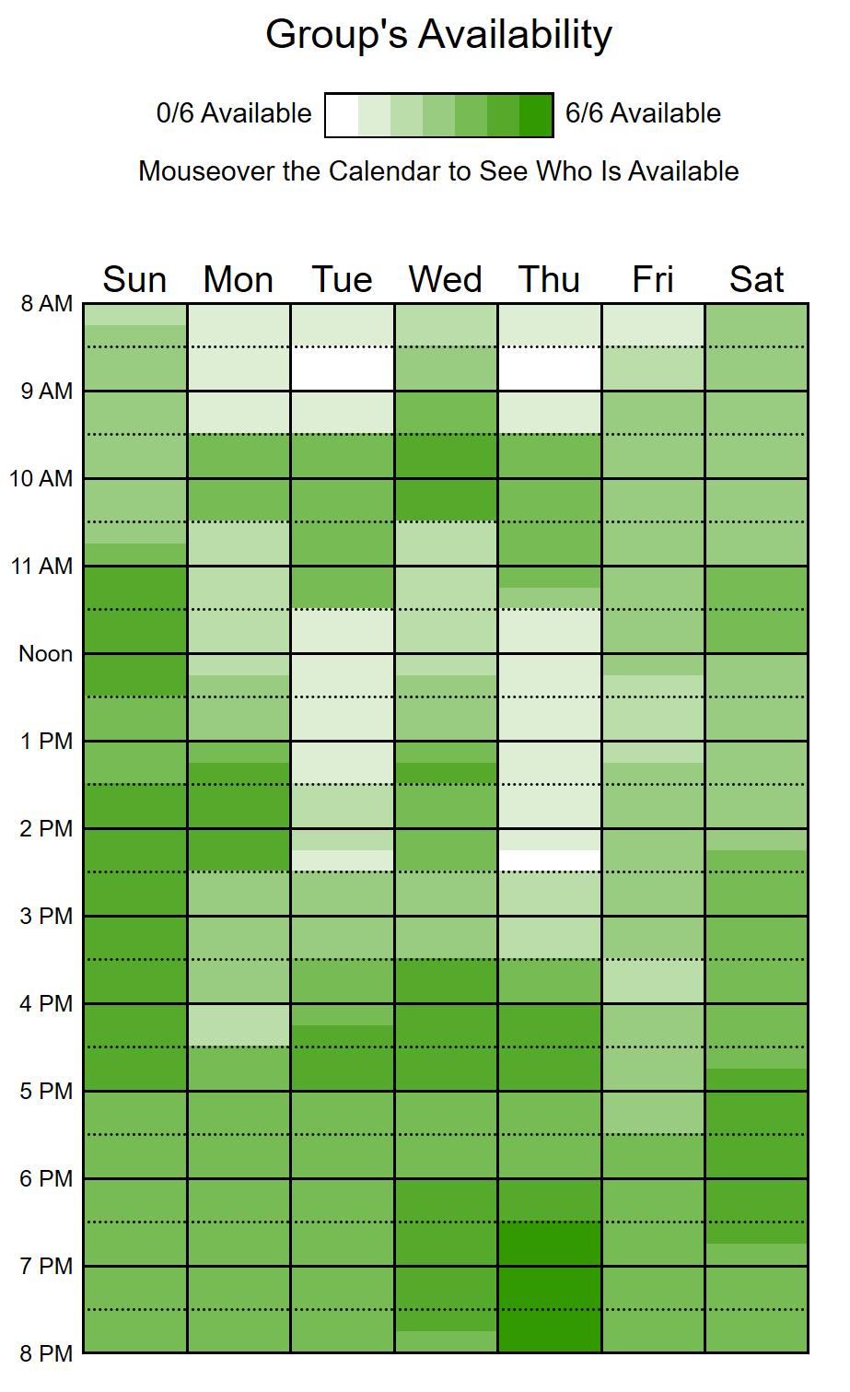
Follow the link for details of every member : https://www.when2meet.com/?8773591-7ut4c
Critical Events
February 25 - Lab 5 Demo
March 02 - March 06 - Study break
March 10 - ECSE321 Midterm
March 20 - Beta Demonstration
April 03 - Final Demo

6.0 – GLOSSARY OF TERMS
- Lego Mindstorms – A lego kit used to build small robots, which can be programmed to perform actions with leJOS EV3 software
- ECSE – Designation for a McGill course in electrical, software, or computer engineering
- Business Case Competition – A competition in which teams of 5-6 present and defend a solution to a given problem

